NETWORKING & SYSTEM ADMINISTRATION LAB

**Name: MELBIN M P**

**Roll No: 19**

**Batch: S2 RMCA B Date: 06-06-2022**

Experiment No: 25 Aim

TCP dump **Procedure Commands:**

$ sudo update && sudo apt install tcpdump

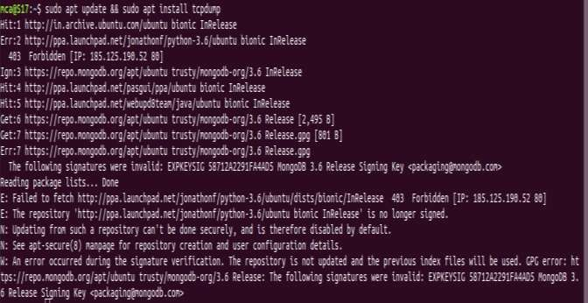

$sudo tcpdump

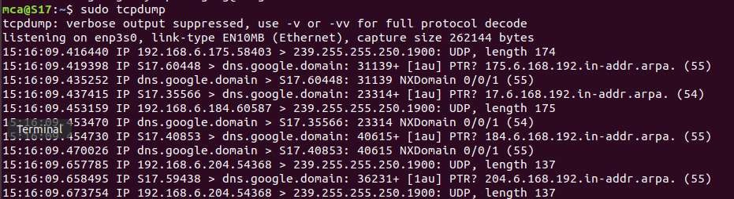

$ sudo tcpdump –D

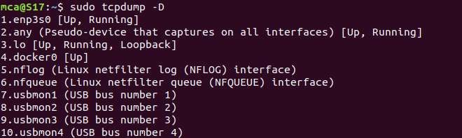

$ sudo tcpdump –i enp3s0

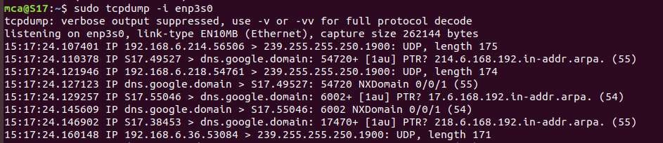

$ sudo tcpdump –c n –I enp3s0

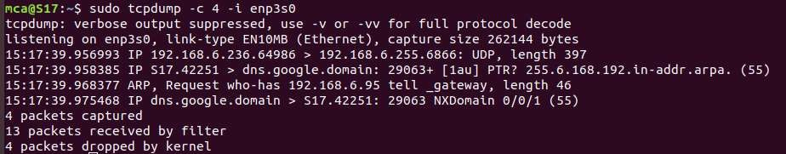

$ sudo tcpdump –xx –I enp3s0

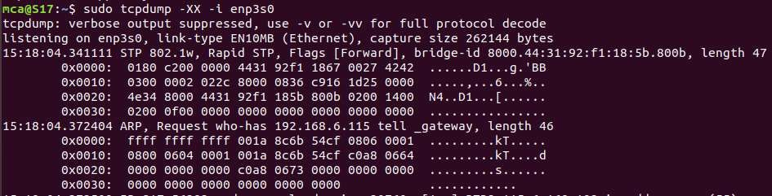

$ sudo tcpdump –i enp3s0 -c n port 80

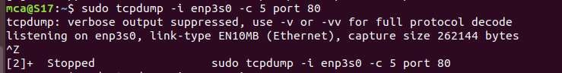

$ sudo tcpdump –i enp3s0 icmp

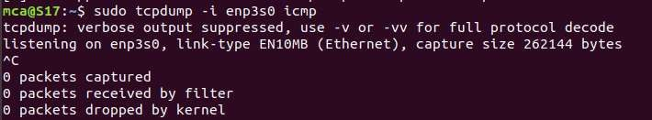

$ sudo tcpdump –i enp3s0 –c n –w icmp.pcap

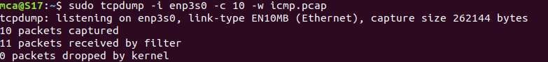

$ tcpdump –r icmp.pcap

